BOY SCOUT TROOP 850

PARENTAL PERMISSION TO PARTICIPATE IN ACTIVITY
AND EMERGENCY MEDICAL AUTHORIZATION

Note: This form signed by a parent or legal guardian must be returned to the Troop in order for the Scout to participate.

I (print name) __________________ hereby authorize my son (print name) ______________________________ to participate in the following activity sponsored by Boy Scout Troop 850:

Type: Backpacking weekend @ Zaleski State Forest
Date: November 10-12th 2023 TURN IN DEADLINE: November 7th
Cost: $20 Payment (check the one that applies) – □ Personal Account □ Online □ Cash/Check
Online Payment Link 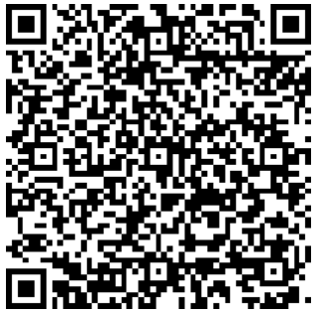
Departure Place and Time: St. Ignatius Friday 5:00 PM
Return Place and Time: St. Ignatius Sunday ~2:00 PM
Adult Leaders: Jim Walro, Brandon Beal, Jeremy Menner
I understand that the Troop will observe all applicable health and safety requirements and procedures during this event (including but not limited to those related to COVID19) and acknowledge that all participants (youth and adult) will also be required to comply with all such requirements and procedures. I also acknowledge and understand that there can be no assurance that such requirements and procedures will necessarily be effective in preventing accidents, injuries or illness (including but not limited to COVID19) and the Troop, its leaders, St. Ignatius or Dan Beard Council will not be responsible or liable for any accidents, injuries or illness (including but not limited to COVID19) any participant may experience during or following the event.

I also hereby authorize the above-named adult leaders to secure any necessary emergency medical treatment for my son in the event I cannot be reached in an emergency and in connection therewith appoint such adult leaders, and each of them, as my attorneys-in-fact to execute in my name and stead such consents, waivers, forms or other documents which may be necessary to secure such medical treatment. My son is covered by the following health insurance:

Name of Carrier: __________________________Policy Number: ___________________

Parent/Guardian Signature: ____________________Phone No.______________________
Check one: ___ I expressly authorize and consent to my son travelling to/from/during this event in any carpool arranged by the Troop OR ___ I will be responsible for transporting my sone to/from/during this event (default if neither option checked.)

Parent plans to participate as follows: 1. Attend? yes_ no _ 2. Assist with driving? yes _ no _
**I understand this campout will be cancelled if there are not enough adults to attend/drive __Yes

