BOY SCOUT TROOP 850

PARENTAL PERMISSION TO PARTICIPATE IN ACTIVITY
AND EMERGENCY MEDICAL AUTHORIZATION

Note: This form signed by a parent or legal guardian must be returned to the Troop in order for the Scout to participate.

I hereby authorize my son, _________________________, to participate in the following activity
(Name)
sponsored by Boy Scout Troop 850:

Type: Klondike Camporee - Camp Michaels in Northern Kentucky

Date: January 16-18, 2026 TURN IN DEADLINE: January 6th, 2026

Cost: $30 (add $2 if using the online payment system)
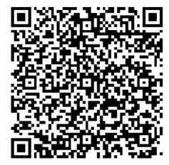
Use Funds in Personal Account? yes __ no __

Departure Place and Time: St. I parking lot, Friday, 5:30 pm

Return Place and Time: St. I parking lot, Sunday, approx 12pm

Adult Leaders: Jeremy Menner, Scott Gilb

I also hereby authorize the above-named adult leaders to secure any necessary emergency medical treatment for my son in the event I cannot be reached in an emergency and in connection therewith appoint such adult leaders, and each of them, as my attorneys-in-fact to execute in my name and stead such consents, waivers, forms or other documents which may be necessary to secure such medical treatment. My son is covered by the following health insurance:

Name of Carrier: __________________________Policy Number: ___________________

Parent/Guardian Signature: ____________________Phone No.______________________
Parent plans to participate as follows: 1. Attend? yes_ no_ Name__________________
2. Assist with driving? yes _ no _

